Chapter 10, Solution 17.

Consider the circuit below.
3 
1 
-j2 
2 
10020 V
+
−
j4 
V₁

V₂

I_{o}

At node 1,
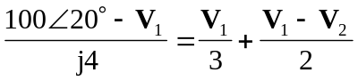
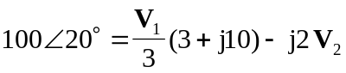 (1)

At node 2,
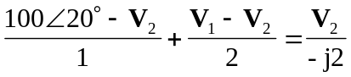
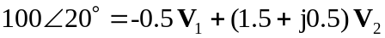 (2)

From (1) and (2),
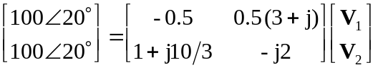

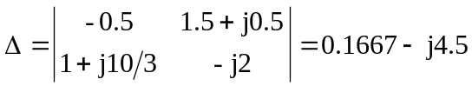

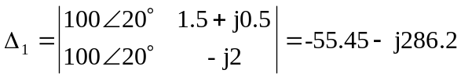

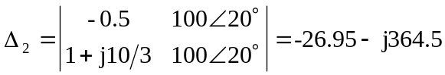

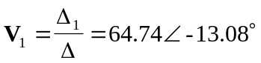
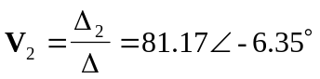
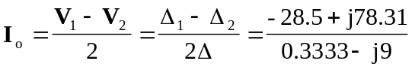

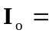 9.25-162.12 A

